SCL website details

**Map**

Map shows six landscapes in different colors, over structural habitat, over indigenous range.

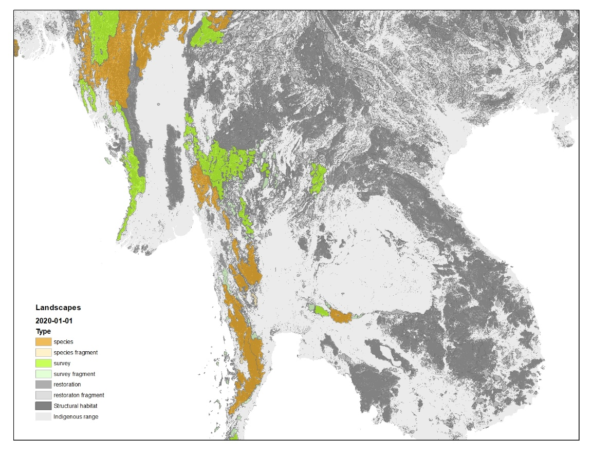

|  |  |  |
| --- | --- | --- |
| Map feature | Dataset | Colors in RGB (happy to discuss) |
| Analysis date | From user selected date; date is used to choose which timepoint to show |  |
| Species conservation landscape | scl_species.geojson | 230/153/0 |
| Species fragment | scl_species_fragment.geojson | 255/235/175 |
| Survey landscape | scl_survey.geojson | 170/255/0 |
| Survey fragment | scl_survey_fragment.geojson | 211/255/190 |
| Restoration landscape | scl_restoration.geojson | 110/110/110 |
| Restoration fragment | scl_restoration_fragment.geojson | 204/204/204 |
| Structural habitat | see examples [here](https://drive.google.com/file/d/1qftWveNtDQnKVIH_VU1v_GxZS8Pvqe2v/view?usp=sharing) | 130/130/130 (the multiple grays are a problem, but not sure what to do… suggestions? |
| Indigenous range | [TCL3_indigenous_range_07302022.shp](https://drive.google.com/file/d/1hS7XiER9SEMEgjeMIeTAGA45gtvUj5ye/view?usp=sharing) | 225/225/225 |

Ideally landscapes/structural habitat/indigenous range can be toggled on/off or faded over choice of basemap

**Top-level graph associated with the web map**

This stacked area graph is plotted with the data from the **landscape area trends** and the known occupied area from the **habitat area trends** tabs of the report, see below.

Note:

Species landscape (occupied) = known occupied area.

Species landscape (occupation uncertain) = Species landscape area – known occupied area.

Survey landscape, restoration landscape, etc. areas are just as calculated for the landscape area trends table and then stacked onto each other.

Colors should match those on the map (see above)

**Downloadable Rangewide Report**

Filename format: SCL + [species name] + [geography] + [report date].xlsx, geography = "range"

Filename example: SCL_Panthera_tigris_range_2022-10-14.xlsx (see attached)

Habitat area trends

A running summary of the habitat areas, starting in 2001. So the "2001_01_01" report would have only one row in the table; "2020-01-01" would have 20 rows. Add header and footer with definitions, notes, and citation (see example).

Example: SCL_Panthera_tigris_range_2022-10-14.xlsx, Habitat area trends tab

Data: scl_states.geojson, polygon

|  |  |  |  |
| --- | --- | --- | --- |
| **Table column name** | **Field in data** | **Treatment** | **Format** |
| Analysis date | (from directory name) | List | string |
| Indigenous resident range | indigenous_range_area | Sum across all records | #,### (round to nearest km2) |
| Structural habitat | str_hab_area | Sum across all records | #,### (round to nearest km2) |
| Effective potential habitat | eff_pot_hab_area | Sum across all records | #,### (round to nearest km2) |
| Known occupied habitat | occupied_eff_pot_hab_area | Sum across all records | #,### (round to nearest km2) |

Notes (which can run above the table if that's easier)

|  |  |
| --- | --- |
| Definitions |  |
| Indigenous resident range | Areas where the species lived **before significant impact from human beings** |
| Structural habitat | Areas within the indigenous range with **appropriate habitat** as determined by land cover type, elevation, and vegetation height |
| Effective potential habitat | Areas of structural habitat with **sufficiently low human influence index** values to increase probability of species persistence |
| Occupied habitat | Areas of effective potential habitat where the species have been observed recently [note 1] |
|  |  |
| Notes |  |
| 1: Occupied habitat based on observations within the last five years of the analysis date | |
|  |  |
| Citation |  |
| Wildlife Conservation Society | |

Landscape area trends

A running summary of the landscape areas, starting in 2001. So the "2001_01_01" report would have only one row in the table; "2020-01-01" would have 20 rows. Add header and footer with definitions, notes, and citation (see example).

Example: SCL_Panthera_tigris_range_2022-10-14.xlsx, Landscape area trends tab

Data: scl_species.geojson, scl_species_fragment.geojson, scl_survey.geojson, scl_survey_fragment.geojson, scl_restoration.geojson, scl_restoration_fragment.geojson

|  |  |  |  |
| --- | --- | --- | --- |
| **Table column name** | **Field in data** | **Treatment** | **Format** |
| Analysis date | (from directory name) | List | String |
| Species conservation landscape | eff_pot_hab_area in scl_species.geojson | Get first record for each lsid, then sum across lsid | #,### (round to nearest km2) |
| Species fragment | eff_pot_hab_area in scl_species_fragment.geojson | As above | As above |
| Survey landscape | eff_pot_hab_area in scl_survey.geojson | Etc. | Etc. |
| Survey fragment | eff_pot_hab_area in scl_survey_fragment.geojson | Etc. | Etc. |
| Restoration landscape | eff_pot_hab_area in scl_restoration.geojson | Etc. | Etc. |
| Restoration fragment | eff_pot_hab_area in scl_restoration_fragment.geojson | Etc. | Etc. |
| Total | Total of "eff_pot_hab_area" from the six geojson files | Total across row of table | #,### (round to nearest km2) |

Notes (which can run above the table if that's easier)

|  |  |
| --- | --- |
| Definitions |  |
| Species conservation landscapes | An interconnected region of effective potential habitat patches with **sufficient area to maintain at least a minimal population [note 1]** and the **species is known to have occurred** **recently** [note 2]. |
| Species fragments | Same as species conservation landscapes, except below the sufficient area size threshold [note 1]. |
| Restoration landscapes | An interconnected region of effective potential habitat with **sufficient area to maintain at least a minimal population** and where the **species is NOT known to have occurred** **recently** or presumed to be extirpated. |
|  |  |
| Notes |  |
| 1 = for tigers, the minimum landscape size is an area greater than what's needed for five, non-overlapping, female home ranges. Estimated female home ranges are allowed to vary across the range depending on biome; | |
| 2 = for tigers, recently is defined within five years of the analysis date. | |

Landscapes

A sorted list of landscapes for an analysis date with name (if available) and summary statistics. Sort by type order, then Effective potential area (largest to smallest), then lsid (smallest to largest).

Type order = species, survey, restoration, species fragment, survey fragment, restoration fragment.

Add header and footer with definitions, notes, and citation (see example).

Example: SCL_Panthera_tigris_range_2022-10-14.xlsx, Landscapes tab.

Data: scl_species.geojson, scl_species_fragment.geojson, scl_survey.geojson, scl_survey_fragment.geojson, scl_restoration.geojson, scl_restoration_fragment.geojson

|  |  |  |  |
| --- | --- | --- | --- |
| **Table column name** | **Field in data** | **Treatment** | **Format** |
| Analysis date | (from directory name) | This date will be the same for every record | string |
| Lsid | lsid  in scl_species …, scl_species_fragment…, etc. | Get each unique lsid. Note that lsid values repeat across types, so "species, lsid = 1" is different from "restoration, lsid = 1" | # |
| Landscape type | (from filename, e.g. species, species fragment, etc., for six types) | Varies by type; see note above. The list under "type order" gives six categories. | String (note includes space, e.g. "restoration fragment") |
| Name | name | Join with the "Tiger Rosetta Stone file" by type and lsid and find name, if exists. If name doesn't exist, leave blank. All species landscapes should have names but most other landscapes types will not have names. | String (variable length) |
| Structural habitat | str_hab_area | Groupby lsid and sum | #,### (round to nearest km2) |
| Effective potential habitat | eff_pot_hab_area | Groupby lsid and sum | #,### (round to nearest km2) |
| Occupied habitat | occupied_eff_pot_hab_area | Groupby lsid and sum | #,### (round to nearest km2) |
| % KBA | kba_eff_pot_hab_area | Groupby lsid and sum then divide by summed eff_pot_hab_area, report as % (0.0 – 100.0) | #.##% |
| % Protected | pa_eff_pot_hab_area | Groupby lsid and sum then divide by summed eff_pot_hab_area, report as % (0.0 – 100.0) | #.##% |

Notes (which can run above the table if that's easier)

|  |  |
| --- | --- |
| Definitions |  |
| Lsid | A unique id for this analysis date and landscape type |
| Landscape type | See definitions on "Landscape area trends" table |
| Name | A name for tracking species landscapes through time |
| Structural habitat | See definitions on "Habitat area trends" table |
| Effective potential habitat | See definitions on "Habitat area trends" table |
| Occupied habitat | See definitions on "Habitat area trends" table |
| % KBA | The percentage of the landscape overlapping a "Key Biodiversity Area" (see www.keybiodiversityareas.org) |
| % Protected | The percentage of the landscape overlapping a protected area (see protectedplanet.net) |
|  |  |
| Notes |  |
|  |  |
|  |  |
| Citation |  |
| Wildlife Conservation Society | |

Species landscape by admin

A list of species landscapes for analysis date with name and percentage of effective potential habitat within each country. The countries are listed across the table alphabetically based on the countries given in the ls_country variable.

Add header and footer with definitions, notes, and citation (see example).

Example: SCL_Panthera_tigris_range_2022-10-14.xlsx, Species landscape by admin tab

Data: scl_species.geojson

|  |  |  |  |
| --- | --- | --- | --- |
| **Table column name** | **Field in data** | **Treatment** | **Format** |
| Analysis date | (from directory name) | This date will be the same for every record | string |
| Lsid | lsid | List each unique lsid for scl_species | # |
| Landscape type | "species" | Repeat "species", see example | String |
| Name | name | Same join as for the "landscapes" table | String (variable length) |
| (variable length list of countries) | country | List full name of each country in columns; note the number and names of columns may vary depending on analysis date; list alphabetically | String (variable length) |
| (table values) | eff_pot_hab_area | Groupby country and sum eff_pot_hab_area and divide by total eff_pot_hab_area for lsid. | #.##% |

No notes

Species landscape by biome

A list of species landscapes for analysis date with name and percentage of effective potential habitat within each biome

Add header and footer with definitions, notes, and citation (see example).

Example: SCL_Panthera_tigris_range_2022-10-14.xlsx, Species landscape by biome tab

Data: scl_species.geojson

|  |  |  |  |
| --- | --- | --- | --- |
| **Table column name** | **Field in data** | **Treatment** | **Format** |
| Analysis date | (from directory name) | This date will be the same for every record | string |
| Lsid | lsid | List each unique lsid for scl_species | # |
| Landscape type | "species" | Repeat "species", see example | String |
| Name | name | Same join as for the "landscapes" table | String (variable length) |
| (variable length list of biomes) | biome_name in ecoregions json (see example of structure below) | Compile unique list of biome_name for each lsid; present in the "biome_order" given below (which is the same as sorting on the "biome_id" field in the json) | String (variable length) |
| (table values) | eff_pot_hab_area in ecoregions json | Groupby lsid and biome_name, sum, and divide by total eff_pot_hab_area for lsid. | #.##% |

Biome order = Tropical & Subtropical Moist Broadleaf Forests, Tropical & Subtropical Dry Broadleaf Forests, Tropical & Subtropical Grasslands, Savannas & Shrublands, Tropical & Subtropical Coniferous Forests, Mangroves, Temperate Broadleaf & Mixed Forests, Temperate Conifer Forests, Flooded Grasslands & Savannas, Montane Grasslands & Shrublands, Boreal Forests/Taiga Deserts, Xeric Shrublands

Example "ecoregions" json structure.

Note "biome_name" = "Temperate Broadleaf & Mixed Forests" is repeated twice, as there are two different ecoregions within that biome.

Note that any given lsid could have multiple "ecoregion" json in the scl_species.geojson file. Which means we need to loop over all the ecoregion json for a given lsid, pull out all the biome name, get the unique list of biome_names, sort them as above, then go back to sum all the eff_pot_hab areas associated with that lsid and that biome across all its pieces.

[

{

"biome_id": 1.000000,

"biome_name": "Tropical & Subtropical Moist Broadleaf Forests",

"connected_eff_pot_hab_area": 41.000000,

"ecoregion_id": 249, "ecoregion_name":

"Mizoram-Manipur-Kachin rain forests",

"eff_pot_hab_area": 42.000000,

"indigenous_range_area": 82.000000,

"occupied_eff_pot_hab_area": 0.000000,

"str_hab_area": 65.000000,

"total_area": 82.000000 },

{

"biome_id": 4.000000,

"biome_name": "Temperate Broadleaf & Mixed Forests",

"connected_eff_pot_hab_area": 7243.000000,

"ecoregion_id": 306,

"ecoregion_name": "Eastern Himalayan broadleaf forests",

"eff_pot_hab_area": 7245.000000,

"indigenous_range_area": 8094.000000,

"occupied_eff_pot_hab_area": 1502.000000,

"str_hab_area": 7730.000000,

"total_area": 8094.000000 },

{

"biome_id": 4.000000,

"biome_name": "Temperate Broadleaf & Mixed Forests",

"connected_eff_pot_hab_area": 35.000000,

"ecoregion_id": 307,

"ecoregion_name": "Northern Triangle temperate forests",

"eff_pot_hab_area": 35.000000,

"indigenous_range_area": 56.000000,

"occupied_eff_pot_hab_area": 7.000000,

"str_hab_area": 41.000000,

"total_area": 56.000000 },

]

[ { "biome_id": 1.000000, "biome_name": "Tropical & Subtropical Moist Broadleaf Forests", "connected_eff_pot_hab_area": 1.000000, "ecoregion_id": 244, "ecoregion_name": "Meghalaya subtropical forests", "eff_pot_hab_area": 1.000000, "indigenous_range_area": 10.000000, "occupied_eff_pot_hab_area": 1.000000, "str_hab_area": 5.000000, "total_area": 10.000000 }, { "biome_id": 1.000000, "biome_name": "Tropical & Subtropical Moist Broadleaf Forests", "connected_eff_pot_hab_area": 93.000000, "ecoregion_id": 222, "ecoregion_name": "Brahmaputra Valley semi-evergreen forests", "eff_pot_hab_area": 93.000000, "indigenous_range_area": 196.000000, "occupied_eff_pot_hab_area": 92.000000, "str_hab_area": 148.000000, "total_area": 196.000000 }